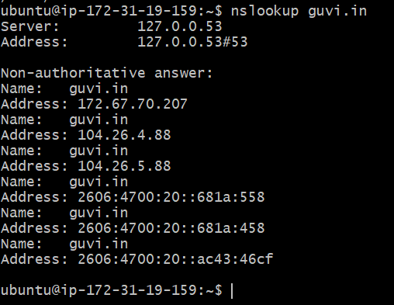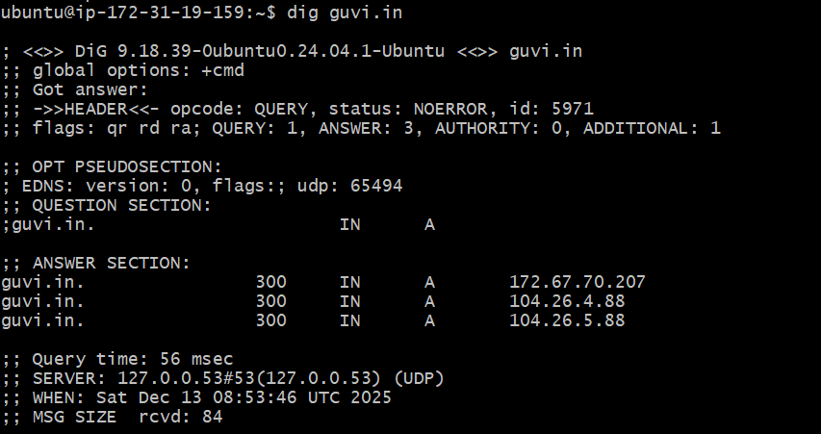
- Nslookup helps us to find the Ip address
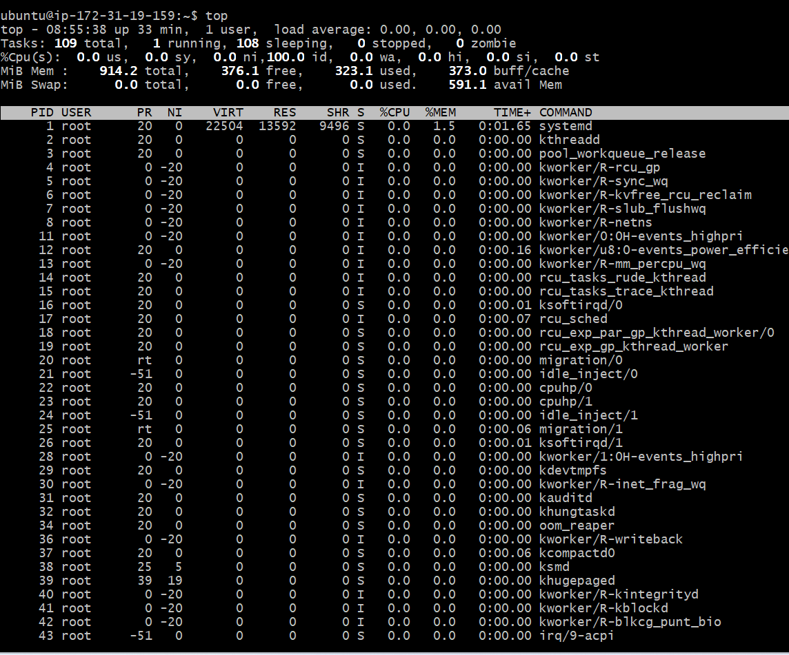
- Use top or htop command to find CPU/memory usage of my server.
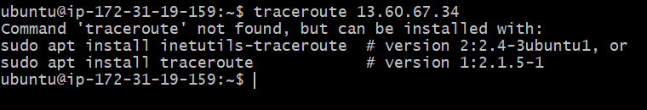
- Command to test connectivity is traceroute

- Unable to find the task two getting error. Need help.

- 